**C Table of Contents**

1. **About the COBRA Import System ................................................................................................... 2**
2. **File Requirements**  **............................................................................................................................ 3** 
   1. Formatting Rules ................................ ........................................................................................ 3
   2. Multiple Employers Files ............................................................................................................. 3
3. **Sending Files Using SFTP ............................................................................................................... 4**
4. **Direct File Import into the COBRA Web Portal ............................................................................... 5**
5. **Version Record Layout .................................................................................................................... 8**
6. **QB (Qualified Beneficiary) Import File Layout ............................................................................... 9**
   1. [QB] ........................................................................................................................................... 9
   2. [QBEVENT] ............................................................................................................................. 13
   3. [QBPLANINITIAL] .................................................................................................................... 15
   4. [QBPLAN] (must be used for bundled plans) ............................................................................ 16
   5. [QBDEPENDENT] - If Applicable.............................................................................................. 19
   6. [QBDEPENDENTPLANINITIAL] - If Applicable ......................................................................... 21
   7. [QBDEPENDENTPLAN] - If Applicable .................................................................................... 21 [QBPLANMEMBERSPECIFICRATEINITIAL] ............................................................................ 24 

6.11 [QBPLANMEMBERSPECIFICRATE] ....................................................................................... 24

1. **NPM (New Plan Member) Import File Layout ................................................................................ 27**
   1. [NPM] ...................................................................................................................................... 26
2. **SPM (Special Plan Member) Import File Layout ........................................................................... 29**
   1. [SPM] ...................................................................................................................................... 29
   2. [SPMPLAN] ............................................................................................................................. 35
   3. [SPMDEPENDENT] ................................................................................................................. 37 8.4 [SPMDEPENDENTPLAN] - If Applicable .................................................................................. 39
   4. [SPMPLANMEMBERSPECIFICRATE] - If Applicable ............................................................... 41

# File Integion Guide

1. About the COBRA Import System

The COBRA Import System accepts and processes electronic data files containing QB events (COBRA events), NPM (active employees enrolled in at least one COBRA-eligible plan), and SPM

(Special Plan Members such as retirees or individuals on LOA, “Direct Bill” participants).

When a file is received it is taken through a process to evaluate the content of the data and identify any errors. This process checks for proper formatting as well as any issues with the data.

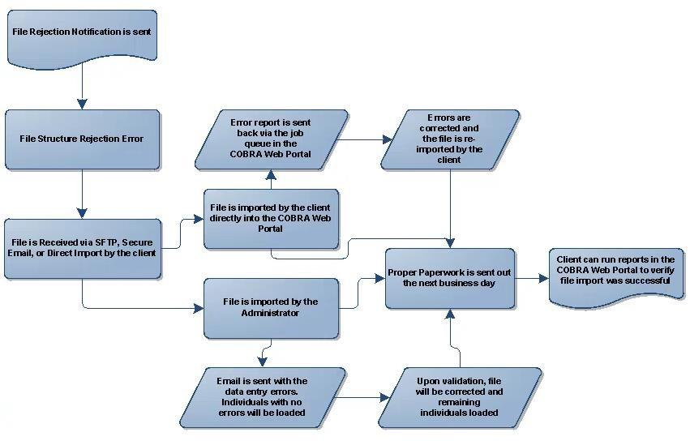

## 2. File Requirements

COBRA files are provided to the system via SFTP, or by the client directly importing the file into the COBRA Web Portal. Discovery Benefits provides the username and password for the SFTP drop location.

### 2.1 Formatting Rules

* The COBRA Import System utilizes a Comma Separated Values (CSV) text file to import information. A CSV file is a text file that contains values on each row that is separated by commas. The file must have the extension .TXT or .CSV.
* Files should contain changes only.
* Fields have specified maximum lengths as indicated in the specification. No zero padding or space padding is necessary unless specified.
* Dollar signs ($) are not supported for currency fields.
* “Valid Values” are the available values for the field. Only these values will be accepted for processing of the file.
* All required fields must be submitted with each file. If a record is sent with values for a required field missing, a file error will populate and that event will not be loaded. The file error will need to be reviewed in the LEAP™ portal. • The file name is limited to 100 characters and should be sent in the following format.

o Test Data File Name: _TEST_YYYYMMDD_GROUPNAME_QB_GPID.txt o Live Data File Name: YYYYMMDD__GROUPNAME_QB_GPID.txt

* + *Include ‘QB’ in the file name if the data on the file is qualified event data.*
  + *Include ‘NPM’ in the file name if the data on the file is new hire data.*
  + *Include ‘SPM’ in the file name if the data on the file is custom/retiree billing.*
  + *All three record types can be included on the same file, or sent on separate files.*

### 2.2 Multiple-Client Files

Multiple clients can be included in a single file. The COBRA Import System will sort the file by employer for processing, saving time by eliminating the need to manually sort files.

To submit a file with records from multiple clients, the following process must be used:

• A unique file naming convention and SFTP log-in will be provided to the vendor/client. This naming convention will need to be used so that Discovery Benefits is aware a multi-client file has been received. • If a client within the file and/or the entire file doesn’t have an events to report, please submit an email to cobraemployerservices@discoverybenefits.com to communicate that the file will be blank.

## 3. Sending Files Using SFTP

The process for sending files using SFTP is as follows:

1. The file is sent to the SFTP site via an automated file transfer process or by manually logging into the SFTP site and uploading the file.
2. The system processes and loads the file upon receipt .
3. An email notification is generated (if configured) once the file has been received.
4. If the file fails initial validation due to an incorrect file format, an email is sent communicating the failure.
5. If the error was caused by a file issue, the file should be corrected and resubmitted to Discovery Benefits.

**Note:** If multiple files are sent (QB, SPM, NPM) please ensure the proper file naming convention is used.

### 4. Direct File Import into the COBRA Web Portal

The process for directly importing files into the COBRA Web Portal:

1. Go to LEAP ® at [https://employer.discoverybenefits.com](https://employer.discoverybenefits.com/)

1. Log in using your assigned username, password and passcode.

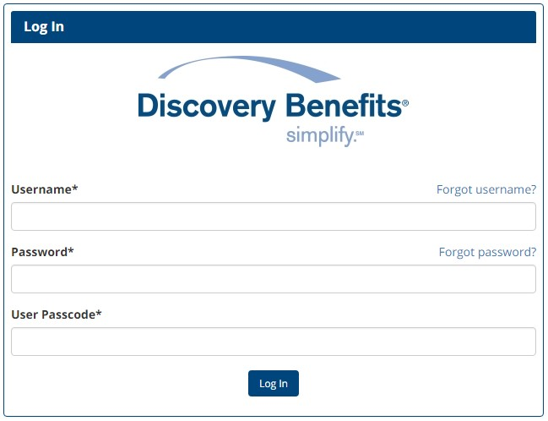

1. From the main menu, click on Administration, and then select COBRA.

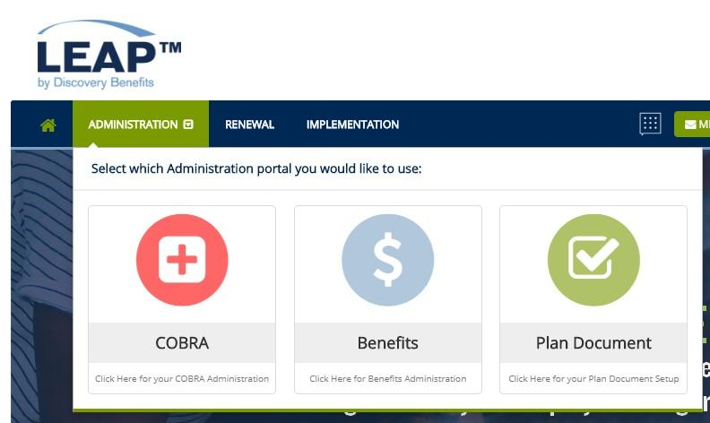

4.

From

the side navigation bar select Imports & Reports, then Imports.

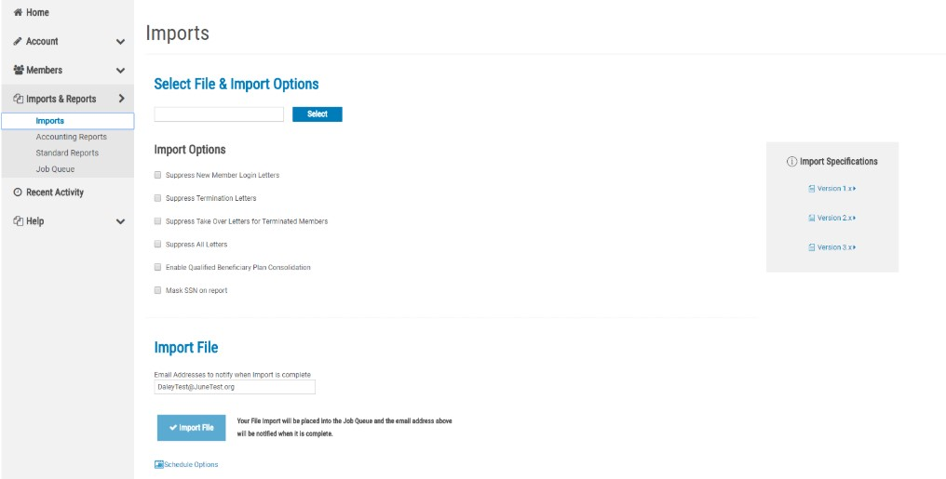

1. Find the location of the saved file by choosing ‘Select’

1. Can specify an email address to notify when the process is complete and schedule import options
2. Select ‘Import File’

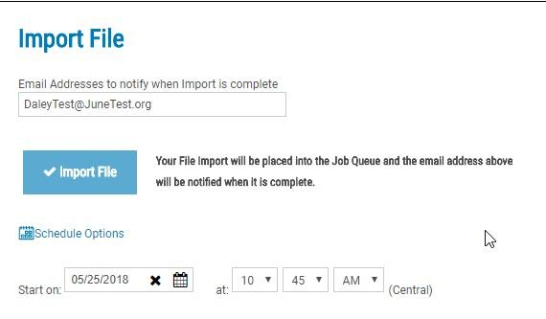

1. This will bring you into the job queue. Please review the report to verify a successful load or if there were any errors.

Below you will find a list of common errors you may receive during the direct import process.

* + Additional commas in a field will cause the record to error out and not import. For example, commas listed in addresses.
  + COBRA start date cannot be equal to or before first day of coverage:
    - Error line type: [QBPLAN]
    - Error language: QBPlan StartDate cannot be before FDOC.
  + First day of active coverage prior to QE date:
    - Error line type: [QB]
    - Error language: Invalid Event Date/Enrollment Date.
  + Plans are not listed on the file for the QB:
    - Error line type: [QB]
    - Error language: No [QBPLAN] or [QBPLANINITIAL] lines in QB definition (QBs must have at least one plan).
  + Invalid coverage level listed on file:
    - Error line type: [QB]
    - Error language: No valid rates in force for coverage level for plan start date.
  + Domestic partner relationship listed incorrectly. Must be listed as DOMESTICPARTNER:
    - Error line type: [QB]
    - Error language: Not a valid relationship DOMESTIC PARTNER. • First day of active coverage missing:
    - Error line type: [QBEVENT]
    - Error language: Error adding row to import table [QBEVENT] – Column ‘EnrollmentDate’ does not allow nulls.
  + Missing coverage level:
    - Error line type: [QBPLAN]
    - Error language: Error parsing import column [NumberOfUnits] for table [QBPLAN]. Input string was not in a correct format. RowData=PlanName=VSP Vision StartDate=7/1/2012 CoverageLevel= • Duplicate plan type:
    - Error line type: [QB]
    - Error language: Violation of UNIQUE KEY constraint ‘tblQBInsuranceTypePlan_UC1’. Cannot insert duplicate key in object ‘dbo.tblQBInsuranceTypePlan’. The statement has been terminated.
  + Participant is listed with FSA plan type but no rate is provided:
    - Error line type: [QB]
    - Error language: You cannot import a NORATE/MEMBERSPECIFICRATE plan without the corresponding [QBPLANMEMBERSPECIFICRATE] line, check that for each [QBPLAN] line that there exists a [QBPLANMEMBERSPECIFICRATE] for each [QBPLAN] line that has a NORATE rate type.

* Dependents are offered a different plan than QB:
  + Error line type: [QB]
  + Error language: Dependent: John,Doe. Failed to compare two elements in the array.
* Event date plans: The qualifying event date must directly proceed the first day of COBRA.
  + Error line type: [QB]
  + Error language: Plan start date of 06/01/2012 would create a break in coverage. This is not allowed.
* NPM hire date: The hire date field must be filled out for members re-hired with the company o Error line type: [NPM]
  + Error language: You must enter a Hire Date for this NPM

## 5. Version Record Layout

Each import file should include a [VERSION] section/tag that identifies what import version the import file is adhering to. If no [VERSION] record exists in the import file, then an error will be generated. QB and NPM files utilize version 1.1. SPM file utilizes 1.2.

**Example:**

[VERSION], 1.1 (No Changes are Needed)

|  |  |  |  |  |  |
| --- | --- | --- | --- | --- | --- |
| **Field Name** | **Version Record Description** | **Format** | **Valid Value(s)** | **Required** | **Mapping Notes** |
| Version | Version of the file format being used. | Alphanumeric | 1.1, 1.2 | Y |  |

## 6. QB (Qualified Beneficiary) Import File Layout

The first field of each line defines what type of information will follow for the fields contained in that line. For instance, a QB record will need a QB line that starts with a line identifier of “[QB]” and might appear something like this:

[QB], My Client Name, My Client Division Name, MR, Bob, L, Jones, 888888888, (etc.)

This QB will also need a line that defines the qualifying event information for the QB. This is accomplished with a line that begins with a line identifier of “[QBEVENT]” and the file might now appear something like this:

[QB], My Client Name, My Client Division Name, MR, Bob, L, Jones, 888888888, (etc.)

[QBEVENT], TERMINATION, 5/1/2008, 1/1/1999, , , (etc.)

All of the lines that follow the “[QB]” line are related to that QB. When a new “[QB]” line is encountered, the previous QB is validated and saved to the database and the new QB begins the import process.

**Note:** For each QB record there must be a [QB], [QBEVENT], and [QBPLAN] record.

### 6.1 [QB] (Client Division Name will be updated)

Example [QB] line:

[QB],My Client Name,My Client Division Name,MR,Bob,L,Jones, 888888888,(etc.)

|  |  |  |  |  |  |
| --- | --- | --- | --- | --- | --- |
| **Field Name** | **Record Description** | **Format** | **Maximum**  **Field**  **Length** | **Mapping Notes** | **Required** |
| Client Name | Unique Client Name assigned by Discovery Benefits. | Alphanumeric | 100 | Toshiba America Inc 29924 | Y |
| Client Division  Name | Unique Client Division Name(s) assigned by Discovery  Benefits. If there are no  Divisions, then use the  ClientName without the five digit code. | Alphanumeric | 50 | If cmpcompanycode = TAES send TAES  If cmpcompanycode = TAI send TAI  All other divisions will need to be removed | Y |
| Salutation | MR, MRS, MS, MISS, DR | Alphanumeric | 35 |  | N |
| First Name | First name of the participant. | Alphanumeric | 50 |  | Y |
| Middle Initial | Middle initial of the participant. | Alphanumeric | 1 |  | N |
| Last Name | Last name of the participant. | Alphanumeric | 50 |  | Y |
| SSN | Social Security Number of the participant.  **Note:** Can include dashes. | Numeric | 11 |  | Y |
| Individual ID | Optional, used to store  Employee ID’s or any other type of secondary identification. | Alphanumeric | 20 |  | N |
| Email | Email address for the participant that will be used for electronic communications to the participant. | Email | 50 |  | N |
| Phone | Primary phone number for the participant – must be formatted as 10 digits.  Note: Can include dashes however no spaces between  numbers | Phone | 10 |  | N |
| Phone 2 | Secondary phone number -  Must be formatted as 10 digits. Note: Can include dashes however no spaces between  numbers | Phone | 10 |  | N |
| Address 1 | Participant’s Address Line 1. **Note:** Do not use commas. | Alphanumeric | 50 |  | Y |
| Address 2 | Participant’s Address Line 2. **Note:** Do not use commas. | Alphanumeric | 50 |  | N |
| City | Name of the city of the participant’s address. | Alphanumeric | 50 |  | Y |
| State or Province | State or province code of the participant’s address.  *For US addresses only, State code should be 2 letters. | Alphanumeric | 50* |  | Y |
| Postal Code | Postal code of the participant’s address. | Alphanumeric | 35 |  | Y |
| Country | Leave blank if the QB resides in the USA.  **Note:** Must be entered for non US residents. | Alphanumeric | 50 |  | N* |
| Premium Address Same As Primary | Set to True if the address to send premium notifications is the same as the QBs main address. | Alphanumeric | 5 |  | Y |
| Premium Address 1 | Deprecated – any value will be ignored. | Alphanumeric | 50 |  | N |
| Premium Address 2 | Deprecated – any value will be ignored. | Alphanumeric | 50 |  | N |
| Premium City | Deprecated – any value will be ignored. | Alphanumeric | 50 |  | N |
| Premium State Or Province | Deprecated – any value will be ignored. | Alphanumeric | 50 |  | N |
| Premium Postal Code | Deprecated – any value will be ignored. | Alphanumeric | 35 |  | N |
| Premium Country | Deprecated – any value will be ignored. | Alphanumeric | 50 |  | N |
| Sex | M, F | Alphanumeric | 1 |  | Y |
| DOB | Date of Birth. MM/DD/YYYY | Date | 10 |  | Y |
| Tobacco Use | Identifies whether or not participant uses tobacco.  YES, NO,  UNKNOWN | Alphanumeric | 35 |  | Y |
| Employee Type | Identifies employment status when participant was an active employee.  FTE, PTE, H1B, CONSULTANT,  SABBATICAL,  PROBATIONARY,  CONTINGENT,  TELECOMMUTING,  INTERN,  GROUPLEADER,  ASSOCIATE,  PARTNER,  UNKNOWN | Alphanumeric | 35 |  | Y |
| Employee Payroll Type | Identifies payroll status when participant was an active employee.  EXECUTIVE,  EXEMPT,  HOURLY,  NONEXEMPT,  SALARY,  UNKNOWN | Alphanumeric | 35 |  | Y |
| Years of Service | *Required if plans are broken out by years of service. | Numeric |  |  | N* |
| Premium Coupon Type | Identifies how participants will be notified of their premiums. **Note:** Used to override client level setting.  PREMIUMNOTICE,  COUPONBOOK,  NONE | Alphanumeric | 35 |  | Y |
| Uses HCTC | True if this QB uses the Health Care Tax Credit system.  (defaults to FALSE)  TRUE, FALSE | Alphanumeric | 5 |  | N |
| Active | COBRA Status. | Alphanumeric | 5 |  | Y |
| Allow Member SSO | DBI does not set up SSO for COBRA members.  \**Optional field and only required if used on the file* | Alphanumeric | 5 |  | Y* |
| Benefit Group | *\*Optional customized field* | Alphanumeric | 50 |  | N* |
| Account Structure | *\*Optional customized field* | Alphanumeric | 50 |  | N* |
| Client Specific Data | *\*Optional customized field* | Alphanumeric | 50 |  | N* |

### 6.2 [QBEVENT] – No Changes Are Needed

Record type used to identify QB’s qualifying event information.

• EventType determines the Category of Event, either Employee or Dependent. Dependent EventTypes are: DIVORCELEGALSEPARATION, DEATH, INELIGIBLEDEPENDENT and MEDICARE. All other EventTypes are Employee.

Example [QBEVENT] line:

[QBEVENT],TERMINATION,5/1/2008,1/1/1999,888888888,,(etc.)

|  |  |  |  |  |  |
| --- | --- | --- | --- | --- | --- |
| **Field Name** | **Record Description** | **Format** | **Maximum**  **Field**  **Length** | **Valid Value(s)** | **Required** |
| Event Type | Type of Qualifying Event.    **Note:** Please refer to available coverage levels in QBPLAN  records to determine coverage level that  would apply to each  QBEvent. Depending on the event the coverage  level may change based on the new QB.  Example: IneligibleDependent event would change  coverage level to EE  Only as the dependent is now the QB. | Alphanumeric | 35 |  | Y |
| Event Date | The date the Qualifying  Event occurred. Do not adjust for plan benefit termination types.  Please use the actual date of the event. | Date MM/DD/YYYY | 10 |  | Y |
| Enrollment Date | Original enrollment date of the member’s plan.  **Note:** Can be any date prior to the event date. | Date  MM/DD/YYYY | 10 |  | Y |
| Employee SSN | The original Employee’s SSN. | SSN | 11 |  | Y |
| Employee Name | The original employee’s Name. | Alphanumeric | 100 |  | Y |
| Second Event  Original  FDOC | Deprecated – any value will be ignored. | Date  MM/DD/YYYY | 10 |  | N |

### 6.3 [QBPLANINITIAL] Plan Names and Coverage Levels will be updated

Simplified record used to enter the plan and coverage level tied to the QB. This record assumes that the QB is on the plan from FDOC (First Day of COBRA) and LDOC (Last Day of COBRA). Do not use this record if there are Bundles (Embedded Plans).

### Send this line for ded codes HCFSA, LPFSA, EAPER, AFDN2, AFVIS, AIDN2, AIDNR, AIVIS, AIVSR

Example [QBPLANINITIAL] line:

[QBPLANINITIAL],Medical Plan,EE+FAMILY,

|  |  |  |  |  |  |
| --- | --- | --- | --- | --- | --- |
| **Field Name** | **Record Description** | **Format** | **Maximum**  **Field**  **Length** | **Valid Value(s)** | **Required** |
| Plan Name | The unique Client plan Name | Alphanumeric | 50 | When EedDedCode = AFDN2 or edhChangeReason = LEVNT3, LEVNT4, 204, 210 or 201, 302 and DbnDedCode = AFDN2 send Delta Dental TX PPO TAES  When EedDedCode = AFVIS and edhChangeReason = LEVNT3, LEVNT4, 204, 210 or 201, 302 and DbnDedCode = AFVIS send VSP TAES  When EedDedCode = AIDN2, AIDNR and edhChangeReason = LEVNT3, LEVNT4, 204, 210 or 201, 302 and DbnDedCode = AIDN2, AIDNR send Delta Dental TX PPO TAI  When EedDedCode = AIVIS, AIVSR and edhChangeReason = LEVNT3, LEVNT4, 204, 210 or 201, 302 and DbnDedCode = AIVIS, AIVSR send VSP TAI  When EedDedCode = HCFSA, LPFSA send DBI Medical FSA  When EedDedCode = EAPER send Magellan Healthcare EAP  All other deduction codes need to be removed | Y |
| Coverage Level | The coverage level for this plan  EE, EE+SPOUSE, EE+CHILD,  EE+CHILDREN, EE+FAMILY,  EE+1, EE+2, EE+DOMESTICPARTNER | Alphanumeric | 35 | When reporting Divorce, Death and Dependent at Max Age Events the Coverage Level for the QB (dependent) will need to be EE  When EedDedCode = AFDN2, AFVIS, AIDN2, AIDNR, AIVIS, AIVSR and  EedBenOption = EE send EE  EedBenOption = EEC send EE+CHILDREN  EedBenOption = EEF, EEDPF send EE+FAMILY  EedBenOption = EES send EE+SPOUSE  EedBenOption = EEDP send EE+DOMESTICPARTNER  When EedDedCode = HCFSA, LPFSA, EAPER send EE | Y |
| Number Of Units | Sets the # of units for this plan. Required if  plan is units based. (e.g. life)  **Note:** Must have two decimal places | Numeric |  | Leave blank | N |

### 6.4 [QBPLAN] – Must use with bundled (embedded) plans – This entire record will need to be added – field mapping values have been added below

### Record used to enter the plan and coverage level tied to the QB. This record is used instead of the [QBPLANINITIAL] record when you need to specify the StartDate/EndDate of the plan, have multiple plans spanning rate periods, use bundles (embedded) plans, or any other scenario where you need to provide more detail during the file import to Discovery Benefits.

### Send this line for ded codes AFMD2, AFMD3, AFMD1, AIMD2, AIMD3, AIMD1, AIMDR instead of the [QBPLANINTIAL] line.

Example [QBPLAN] line:

[QBPLAN],Medical Plan,12/1/2011,,EE+FAMILY,,,,,,,,,,,,

|  |  |  |  |  |  |
| --- | --- | --- | --- | --- | --- |
| Field Name | Record Description | Format | Maximum FieldLength | Valid Value(s) | Required |
| Plan Name | The unique Client plan Name | Alphanumeric | 50 | When EedDedCode = AFMD2 or edhChangeReason = LEVNT3, LEVNT4, 204, 210 or 201, 302 and DbnDedCode = AFMD2 send BCBSTX CDHP + HCA TAES/RxWhen EedDedCode = AFMD3 or edhChangeReason = LEVNT3, LEVNT4, 204, 210 or 201, 302 and DbnDedCode = AFMD3 send BCBSTX CDHP + HSA TAES/RxWhen EedDedCode = AFMD1 or edhChangeReason = LEVNT3, LEVNT4, 204, 210 or 201, 302 and DbnDedCode = AFMD1 send BCBSTX EPO1 TAES/RxWhen EedDedCode = AIMD2 and edhChangeReason = LEVNT3, LEVNT4, 204, 210 or 201, 302 and DbnDedCode = AIMD2 send BCBSTX CDHP + HCA TAI/RxWhen EedDedCode = AIMD3 and edhChangeReason = LEVNT3, LEVNT4, 204, 210 or 201, 302 and DbnDedCode = AIMD3 send BCBSTX CDHP + HSA TAI/RxWhen EedDedCode = AIMD1, AIMDR and edhChangeReason = LEVNT3, LEVNT4, 204, 210 or 201, 302 and DbnDedCode = AIMD1, AIMDR send BCSBTX EPO1 TAI/Rx | Y |
| Start Date | The start date that the QB will begin coverage on this plan. This shouldbe set to the First Day of COBRAMM/DD/YYYY | Date | 10 | eedbenstopdate + 1 day | Y |
| End Date | Optional, the end date the QB will ceasecoverage on this plan. (*leave this field blank*)MM/DD/YYYY | Date | 10 | leave blank | N |

|  |  |  |  |  |  |
| --- | --- | --- | --- | --- | --- |
| Coverage Level | The coverage level for this plan | Alphanumeric | 35 | When reporting Divorce, Death and Dependent at Max Age Events the Coverage Level for the QB (dependent) will need to be EEWhen EedDedCode = AFMD2, AFMD3, AFMD1, AIMD2, AIMD3, AIMD1, AIMDREedBenOption = EE send EEEedBenOption = EEC send EE+CHILDRENEedBenOption = EEF, EEDPF send EE+FAMILYEedBenOption = EES send EE+SPOUSEEedBenOption = EEDP send EE+DOMESTICPARTNER | Y |
| First Day OfCOBRA | Used to override the system calculatedFDOC. If left blank, the system will determine FDOC based on theEvent Date and plan benefit termination type | Date | 10 | leave blank | N |
| Last Day OfCOBRA | (*leave this field blank*) The system will determine LDOC based on the FDOC andCOBRA Duration Months | Date | 10 | leave blank | N |
| COBRADurationMonths | (*leave this field blank*) Number of COBRA eligible months. The system will determine the correct number ofmonths based on Event Type. | Numeric | 2 | leave blank | N |
| Days To Elect | (*leave this field blank*) Number of days the QB has available to elect coverage underCOBRA. The system will determine the correct number of days. | Numeric | 3 | leave blank | N |
| Days To Make 1st Payment | (*leave this field blank*) Number of days the QB has to make their 1st full payment under COBRA. The system will determine the correct number of days | Numeric | 3 | leave blank | N |
| Days To MakeSubsequentPayments | (*leave this field blank*) Number of days the QB has to make their next payments under COBRA. | Numeric | 3 | leave blank | N |
| Election Postmark Date | (*leave this field blank*) | Date | 10 | leave blank | N |
| Last Date Rates Notified | (*leave this field blank*) | Date | 10 | leave blank | N |
| Number Of Units | Sets the # of units for this plan. Required ifplan is units based. (e.g. life)Note: Must have two decimal places | Numeric |  | leave blank | N |
| Send PlanChange Letter For Legacy | (*default to false*) | Alphanumeric | 5 | False | Y |
| Plan Bundle Name | *Required only for bundled (embedded)plans | Alphanumeric | 50 | leave blank | N* |

### 

### 

### 6.5 [QBDEPENDENT] No Changes Are Needed

Example [QBDEPENDENT] record:

[QBDEPENDENT],888888888,SPOUSE,,Jane,M,Johnson,jjohnson@noemail.com,,,,(etc.)

|  |  |  |  |  |  |
| --- | --- | --- | --- | --- | --- |
| **Field Name** | **Record Description** | **Format** | **Maximum**  **Field**  **Length** | **Valid Value(s)** | **Required** |
| SSN | Social Security  Number of the dependent. | Numeric | 11 |  | Y |
| Relationship | Relationship to the QB  (Use CHILD for adopted, disabled, or step children.  SPOUSE, CHILD, DOMESTICPARTNER | Alphanumeric | 35 |  | Y |
| Salutation | MR, MRS, MS, MISS, DR | Alphanumeric | 35 |  | N |
| First Name | First name of the dependent | Alphanumeric | 50 |  | Y |
| Middle Initial | Middle initial of the dependent. | Alphanumeric | 1 |  | N |
| Last Name | Last name of the dependent. | Aphanumeric | 50 |  | Y |
| Email | Email address for the dependent that will be used for electronic  communications to the dependent. | Alphanumeric |  |  | N |
| Phone | Primary phone number for the dependent –  must be formatted as 10 digits.  Note: Can include dashes however no  spaces between numbers | Phone | 10 |  | N |
| Phone 2 | Secondary phone number - Must be  formatted as 10 digits. Note: Can include dashes however no  spaces between numbers | Numeric | 10 |  | N |
| Address Same As QB | Set to True if the Dependent’s address is the same as the QB. | Alphanumeric | 5 |  | Y |
| Address 1 | Dependent’s Address Line 1.  **Note:** Do not use commas. | Alphanumeric | 50 |  | N |
| Address 2 | Dependent’s Address Line 2.  **Note:** Do not use commas. | Alphanumeric | 50 |  | N |
| City | Name of the city of the dependent’s address. | Alphanumeric | 50 |  | N |
| State Or Province | State or province code of the dependent’s address.  *For US addresses only, State code should be 2 letters. | Alphanumeric | 50* |  | N |
| Postal Code | Postal code of the dependent’s address. | Alphanumeric | 35 |  | N |
| Country | Leave empty if the  Dependent resides in the USA. | Alphanumeric |  |  |  |
| Enrollment Date | (*leave this field blank*) The enrollment date from the QB will be used.  MM/DD/YYYY | Date | 10 |  | N |
| Sex | M, F | Alphanumeric | 1 |  | Y |
| DOB | Date of Birth | Date  MM/DD/YYYY | 10 |  | Y |
| Is QMCSO | True if the dependent is under a Qualified  Medical Child Support Order. | Alphanumeric | 5 |  | Y |

### 6.6 [QBDEPENDENTPLANINITIAL] – Plan Names will be updated

Simplified record used to enter the QB’s dependent onto the applicable plan. This assumes the dependent is on the plan from the First Day of COBRA (FDOC) through the Last Day of COBRA (LDOC).

### Send this line for ded codes AFDN2, AFVIS, AIDN2, AIDNR, AIVIS, AIVSR

Example [QBDEPENDENTPLANINITIAL record:

[QBDEPENDENTPLANINITIAL],Medical Plan

|  |  |  |  |  |  |
| --- | --- | --- | --- | --- | --- |
| **Field Name** | **Record Description** | **Format** | **Maximum**  **Field**  **Length** | **Valid Value(s)** | **Required** |
| Plan Name | The unique Client plan Name. | Alphanumeric | 50 | When DbnDedCode = AFDN2 send Delta Dental TX PPO TAES  When DbnDedCode = AFVIS send VSP TAES  When DbnDedCode = AIDN2, AIDNR send Delta Dental TX PPO TAI  When DbnDedCode = AIVIS, AIVSR send VSP TAI  All other deduction codes need to be removed | Y |

### 6.7 [QBDEPENDENTPLAN] This will be Added to the File

Advanced record used to enter the QB’s dependent onto the applicable plan assuming the dependent will go on or off the plan over time. Use [QBDEPENDENTPLANINITIAL] for dependents that will be on the plan for the entire period of coverage.

### Send this line for ded codes AFMD2, AFMD3, AFMD1, AIMD2, AIMD3, AIMD1, AIMDR instead of the [QBDEPENDENTPLANINITIAL] line.

Example [QBDEPENDENTPLAN] record:

[QBDEPENDENTPLAN],Medical Plan,01/01/2015,,True

|  |  |  |  |  |  |
| --- | --- | --- | --- | --- | --- |
| **Field Name** | **Record Description** | **Format** | **Maximum**  **Field**  **Length** | **Valid Value(s)** | **Required** |
| Plan Name | The unique Client plan Name. | Alphanumeric | 50 | When DbnDedCode = AFMD2 send BCBSTX CDHP + HCA TAES/Rx  When DbnDedCode = AFMD3 send BCBSTX CDHP + HSA TAES/Rx  When DbnDedCode = AFMD1 send BCBSTX EPO1 TAES/Rx  When DbnDedCode = AIMD2 send BCBSTX CDHP + HCA TAI/Rx  When DbnDedCode = AIMD3 send BCBSTX CDHP + HSA TAI/Rx  When DbnDedCode = AIMD1, AIMDR send BCSBTX EPO1 TAI/Rx | Y |
| Start Date | The start date of the dependent on the plan. This should be set to the First Day of COBRA. | Date | 10 | **eedbenstopdate + 1 day** | Y |
| End Date | The end date of the dependent on the plan. This should be set to the Last Day of COBRA  unless the dependent will be ending the plan before LDOC. | Date | 10 | Leave Blank | N |
| Uses FDOC | Set to True if the dependent plan starts on the QB’s FDOC. | Alphanumeric | 5 | True | Y |

### 6.10 [QBPLANMEMBERSPECIFICRATEINITIAL] - Plan Name Changes

Simplified record used to enter a member specific rate for a plan. It assumes that the rate will be applied from FDOC through LDOC. Only use with [QBPLANINITIAL]. Does not work with [QBPLAN].

Example [QBPLANMEMBERSPECIFICRATEINITIAL] record:

[QBPLANMEMBERSPECIFICRATEINITIAL],Medical FSA,50.00

|  |  |  |  |  |  |
| --- | --- | --- | --- | --- | --- |
| **Field Name** | **Record Description** | **Format** | **Maximum**  **Field**  **Length** | **Valid Value(s)** | **Required** |
| Plan Name | The unique Client plan name. | Alphanumeric | 50 | When EedDedCode = HCFSA, LPFSA send DBI Medical FSA | Y |
| Rate | The amount of the member specific rate.  **Note:** Must include two decimal places. | Numeric |  | When EedDedCode = HCFSA, LPFSA send EEAmt | Y |